Page URL - https://rootcabs.com/book-a-ride
Slug Suggestion - https://rootcabs.com/book-ride
Primary Keyword
book your ride
book a ride online
Secondary & LSI Keywords
book airport shuttle
booking transfer airport
book ride
book airport transportation
online ride booking
online bike ride booking
booking ride
book a transfer from airport
bike ride booking online
book to ride
book your ride online
online car ride booking
ride book online
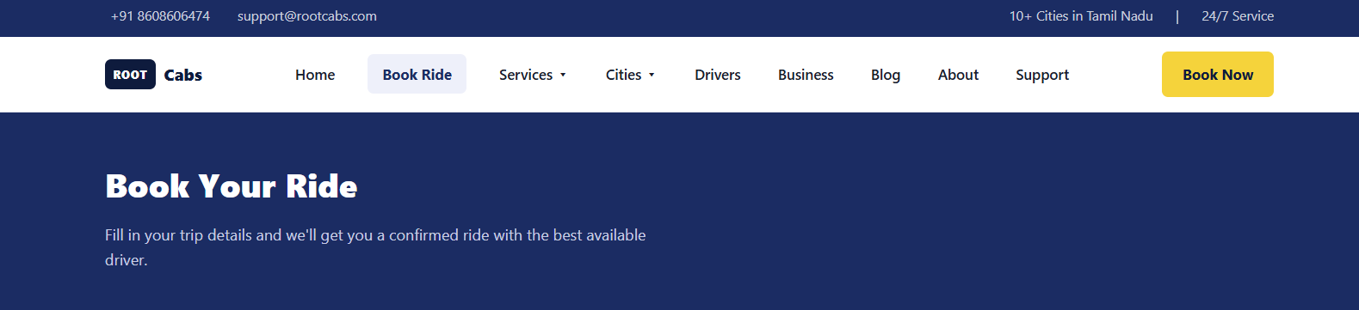

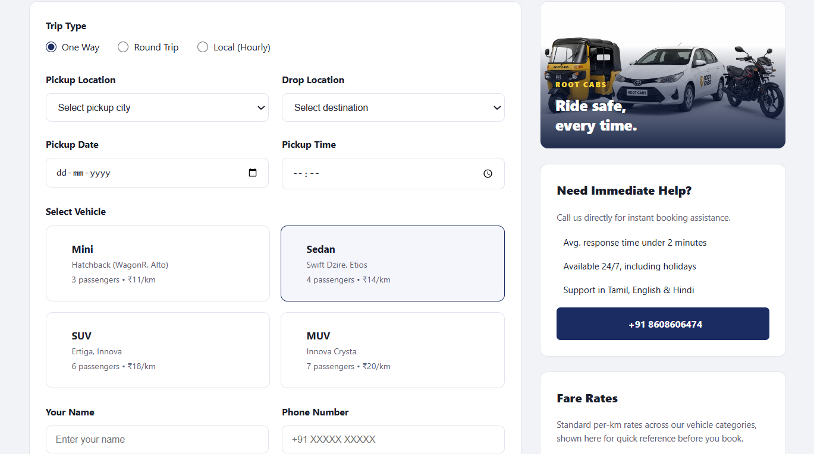

Need Immediate Help - needs a content enhancement

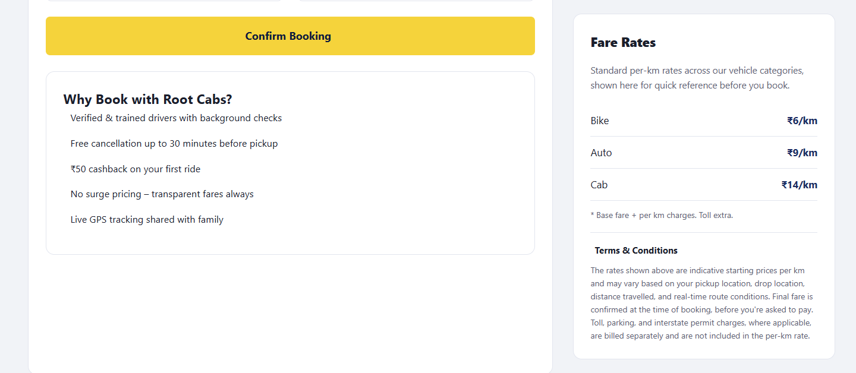

Add a Root cabs in this section also utilize this for beneficial - add a benefits

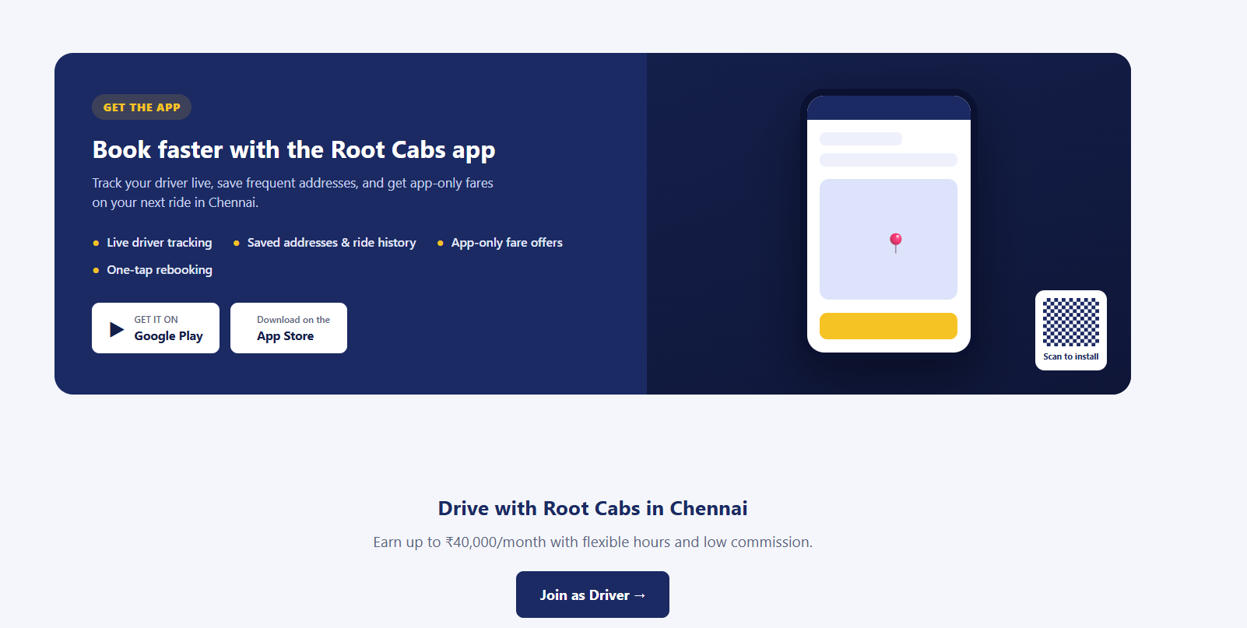

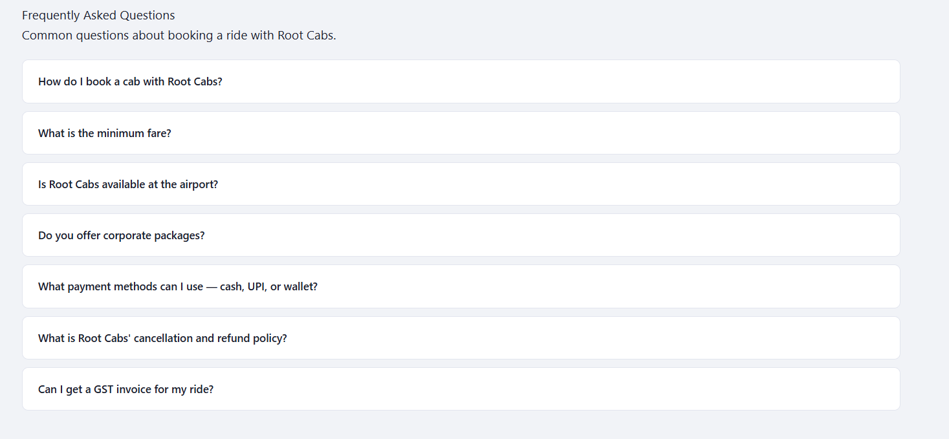

FAQ
What is a drop taxi, and does Root Cabs offer one-way drop taxi service?
How do I book the cheapest drop taxi near me?
How much does a drop taxi to Chennai cost?
What's the cheapest cab service option in Chennai?
Can I book a cab or an auto online with Root Cabs?
Do you offer a car rental package for multiple days?
Can I add multiple pickup points in one booking, like picking up friends from different locations?

